



*Stream*

*Music*

*Anywhere*

**eProject**

Group Members

|  |  |
| --- | --- |
| **Student ID** | **Student Name** |
| **Student1274255** | SHEIKH ABDULLAH |
| **Student1287890** | HAFIZ MUHAMMAD HAMZA ALI |

**CURRICULUM**

6740

**BATCH**

2011G3

**FACULTY**

Ms. Sana Sheeraz

## ADMIN PANEL

Tools:

* View, Create, Edit and Delete website Administrators
* View, Create, Edit and Delete Users
* View, Create, Edit and Delete Music
* View, Create, Edit and Delete Albums
* View, Create, Edit and Delete Artists
* View Music Reviews made from users

Additional Features:

* Authenticate Admins with their Email and Password
* Form validation
* Dashboard

**Albums List Page**

## THE END

## T H A N K Y O U

* Admin can view all albums
* Admin can delete any album directly from this page.
* Add new and Edit links are given.

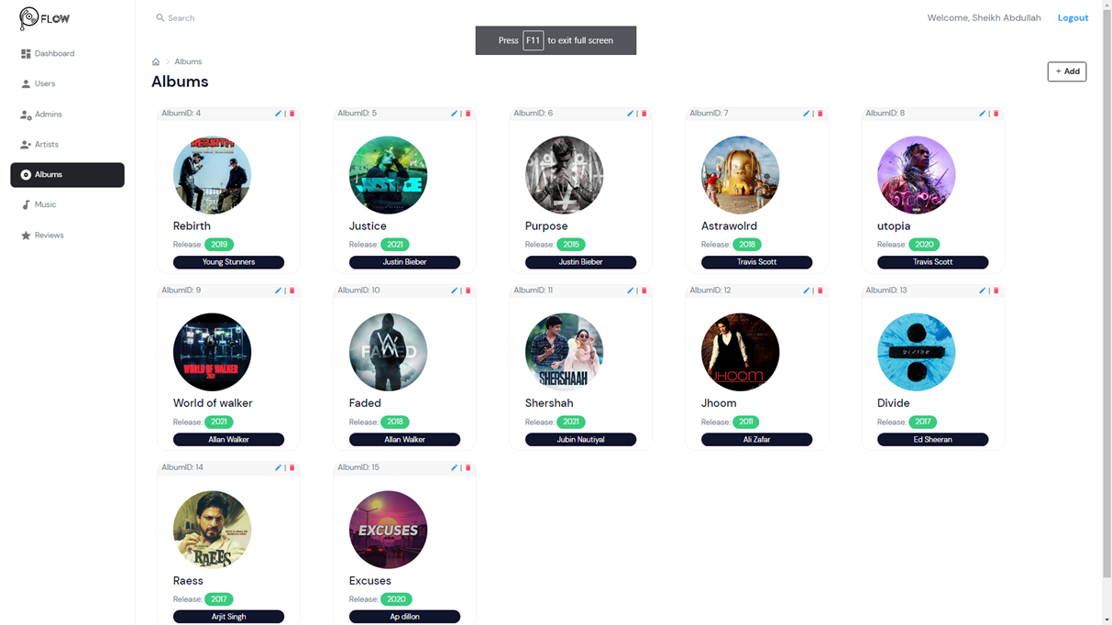

**Music List Page**

* + - Admin can view all music.
    - Admin can delete any music directly from this page.
    - Add new and Edit links are given.

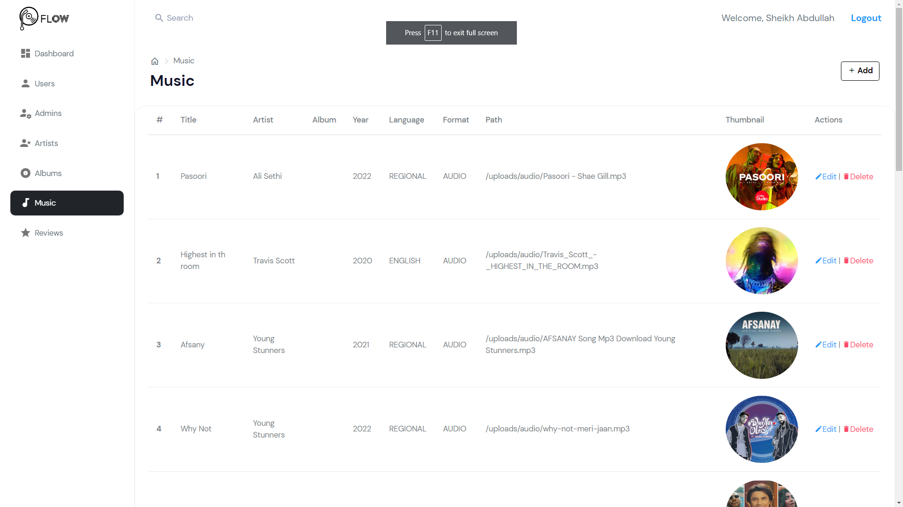

**Adding a new record**

* + - Click on “Add” button on top-right corner.
    - Fill all the details.
    - Press submit to submit the new record

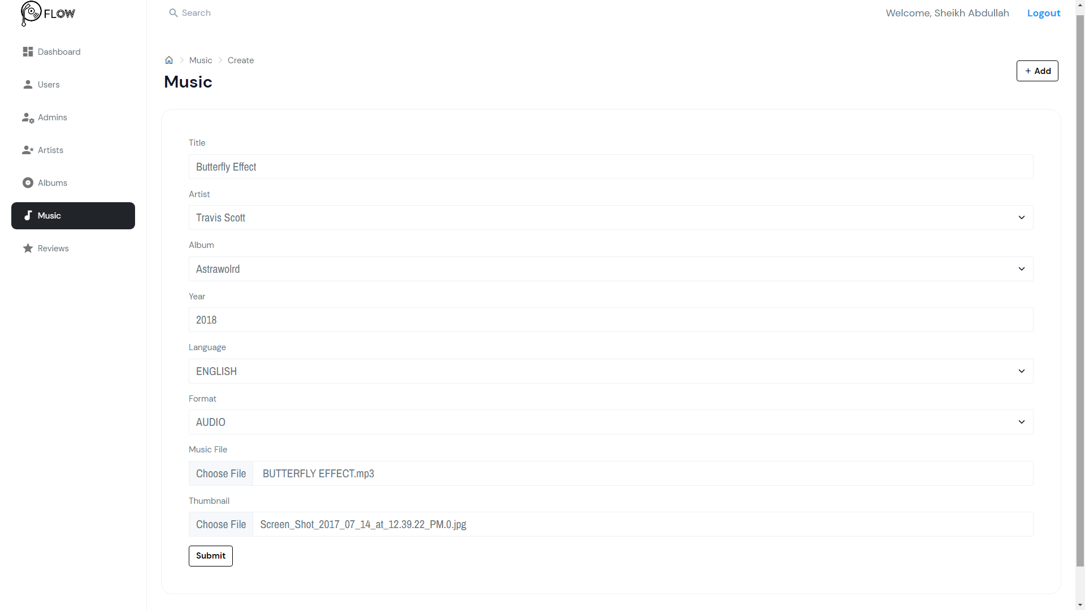

**Updating details of record**

* + - Click “Edit” button to go Editing Page.
    - Update the record you wish to change and leave others.
    - Press “Submit” when done.

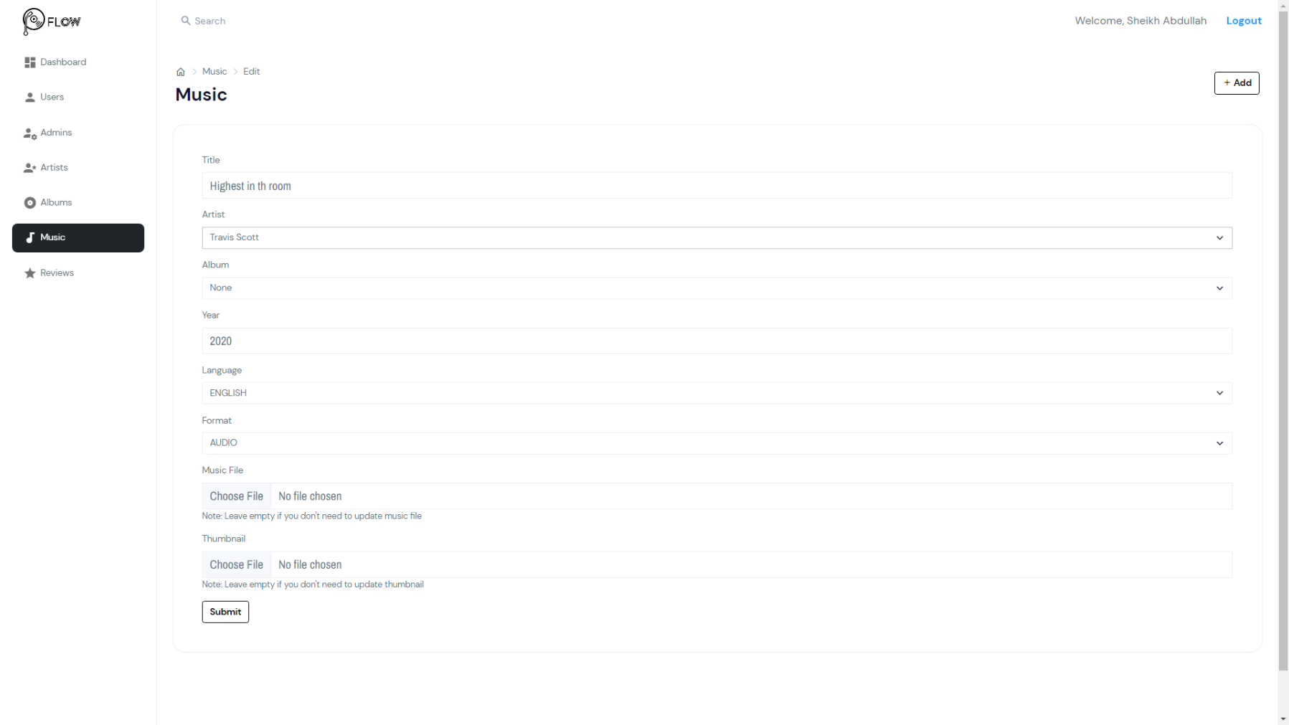

## THE END

## T H A N K Y O U